**DAILY ONLINE ACTIVITIES SUMMARY**

|  |  |  |  |  |  |  |  |  |
| --- | --- | --- | --- | --- | --- | --- | --- | --- |
| **Date:** | **13-06-2020** | | | | | **Name:** | **Anix Jugal D’Cunha** | |
| **Sem & Sec** | **8 sem , A sec** | | | | | **USN:** | **4AL16CS013** | |
| **Online Test Summary** | | | | | | | | |
| **Subject** | | **IOT** | | | | | | |
| **Max. Marks** | | **30** | | **Score** | | | **30** | |
| **Certification Course Summary** | | | | | | | | |
| **Course** | **Java Beginner's Bootcamp 2020** | | | | | | | |
| **Certificate Provider** | | | **Udemy** | | **Duration** | | | 36 mins |
| **Coding Challenges** | | | | | | | | |
| **Problem Statement:** Python Program to Merge Mails | | | | | | | | |
| **Status: Competed** | | | | | | | | |
| **Uploaded the report in Github** | | | | | **yes** | | | |
| **If yes Repository name** | | | | | **alvas-education-foundation/dcunhaanixjugal** | | | |
| **Uploaded the report in slack** | | | | | **yes** | | | |

Online Test Details: (Attach the snapshot and briefly write the report for the same)

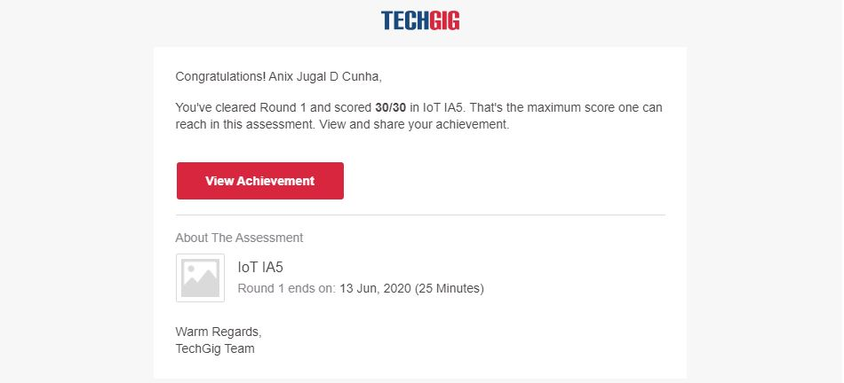

Certification Course Details: (Attach the snapshot and briefly write the report for the same)

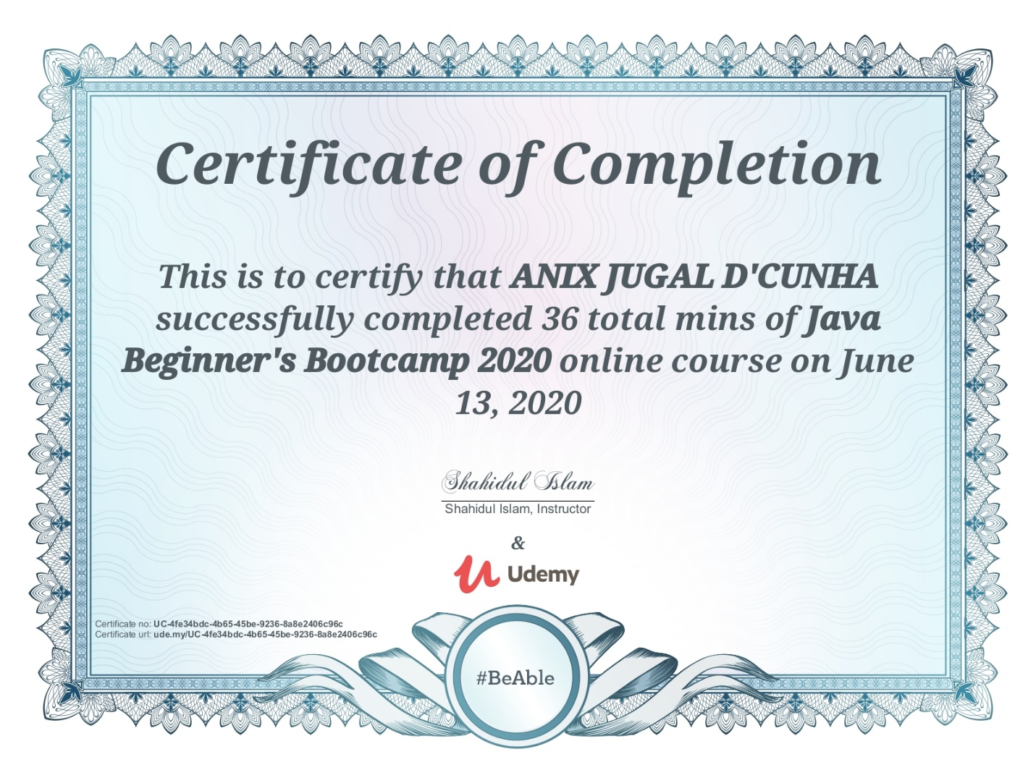

Coding Challenges Details: (Attach the snapshot and briefly write the report for the same)

Program-> Python Program to Merge Mails

|  |
| --- |
|  |
|  | # Python program to mail merger |
|  | # Names are in the file names.txt |
|  | # Body of the mail is in body.txt |
|  |  |
|  | # open names.txt for reading |
|  | with open("names.txt",'r',encoding = 'utf-8') as names_file: |
|  |  |
|  | # open body.txt for reading |
|  | with open("body.txt",'r',encoding = 'utf-8') as body_file: |
|  |  |
|  | # read entire content of the body |
|  | body = body_file.read() |
|  |  |
|  | # iterate over names |
|  | for name in names_file: |
|  | mail = "Hello "+name+body |
|  |  |
|  | # write the mails to individual files |
|  | with open(name.strip()+".txt",'w',encoding = 'utf-8') as mail_file: |
|  | mail_file.write(mail) |